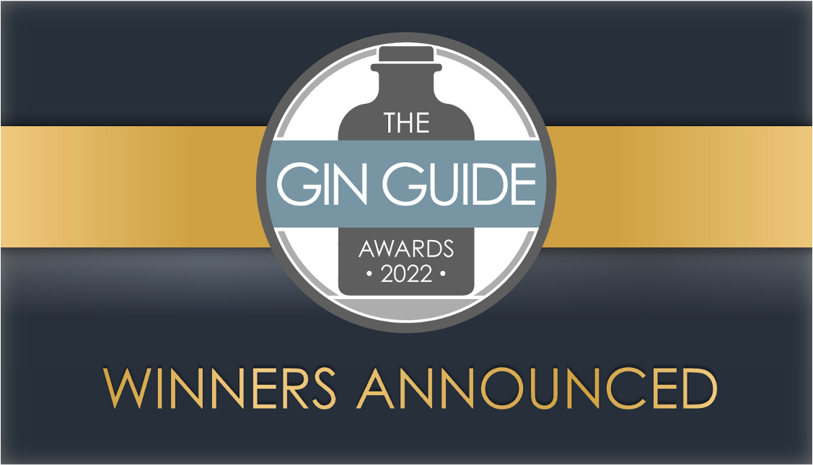

The Winners of The Gin Guide Awards 2022 have been revealed in a highly anticipated announcement that has grabbed the attention of the spirits industry. In particular, the quality from up-and-coming distilleries and the international diversity of the Winners has been eye-catching as the popularity and standard of gins from emerging gin markets - from North Macedonia, Slovenia and Hungary to New Zealand, South Africa and Ecuador - has reached new levels alongside a strong showing of Winners from the UK.
Hundreds of gins from over 30 countries around the world took part in The Gin Guide Awards 2022, in categories based on the most popular styles of gin and their countries of production, as well as Design & Branding and Environmental Sustainability categories.
The Winners are selected through a rigorous blind tasting process conducted by an esteemed panel of distinguished gin experts, including spirits buyers for retailers, distillers, authors, and mixologists. Each gin’s appearance, aroma, flavour, mouthfeel, finish and overall quality and market appeal are assessed to determine the highest scoring gins, based purely on the spirit itself and with no influence from branding, marketing or country of origin.
Global awards shine a spotlight on the quality of British gins while international gins rise to the challenge in style:
Broken Bones Distillery in Ljubljana took centre stage with the ‘Distillery of the Year 2022’ Award, making them the first Winner of this coveted title from outside of the UK, as well as being Winners in the Contemporary Gin, Navy Strength Gin, Old Tom Gin and Aged Gin categories. Meanwhile, Puddingstone Distillery in Hertfordshire and Stockport Gin from Manchester both impressively repeated the feat of being multiple Winners having done so in 2020 and 2021.
1881 Distillery in Scotland and The Henley Distillery were Winners in multiple categories, with The Henley Distillery in Oxfordshire also being named ‘New Distillery of the Year 2022’ having launched last year. Hungary’s Tokaj Gin was named ‘Product of the Year 2022’ after success in both the Contemporary Gin blind tasting category and the Design & Branding category, adding to the gin from Seven Hills Distillery being the highest scoring European Gin and claiming the ‘Best in Europe 2022’ accolade.
It was a repeat Award-Winner that rose further this year to claim the ‘Best in Britain 2022’ Award for the first time - Stockport Gin’s Twist of Lime Edition achieved exceptional scores from every Judge for the 3rd consecutive year, continuing to impress with the larger Judging Panels and a host of new expert Judges assessing it this year.
That Spirited Lot Distillers’ Vintage on the Ninch Gin was named ‘Best in Australia 2022’, The National Distillery Company’s New Zealand Dry Gin was named ‘Best in New Zealand 2022’, Unit 43 Original Gin was awarded ‘Best in Africa 2022’ for a 3rd year running, Tanglin Singapore Gin from scooped ‘Best in Asia 2022’, and ‘Best in The Americas 2022’ went to ‘Lixir – The Mountain Gin’ from Ecuador.
The full list and details of Winners, Highly Commended entrants and geographic high scorers for each category are available on The Gin Guide website, as well as contact and website details for each Winner, and a printable ‘Winners Checklist’ for gin lovers to tick off the gins as they try each of them:
- https://www.theginguide.com/2022-winners.html
The Gin Guide Awards – The world’s largest dedicated gin competition:
Now in its 6th year, The Gin Guide Awards is an independent, celebration of the historic, diverse and growing worldwide gin industry. Recognised and respected globally by the trade and consumers alike for its rigorous and quality-focused approach and industry-leading judging panels, The Gin Guide Awards serves to highlight the exceptional products, distilleries and people within the gin industry across the world. Keep an eye out for 2022 Winners and past Winners displaying their Awards proudly on their bottles, packaging, exhibition stands and marketing materials.
Head Judge Paul Jackson, the Founder and Editor of The Gin Guide, commented on The Gin Guide Awards 2022 and the standard of entries:
“The quality and diversity of gins has been absolutely remarkable. British gins and international gins alike showed the depth of skill in distillation and product development that exists in the industry and that is undoubtedly becoming more prevalent in emerging gin markets. Gins from new and growing markets hugely impressed the industry-leading judging panels and showed that gin can truly cross borders and be an exciting product in markets across the world that are traditional more connected with other spirits.”
“Huge congratulations and credibility go to all the Winners, Highly Commended gins and Finalists. The Gin Guide Awards names a very small number of Winners in each category to ensure genuine exclusivity and to protect the value of the awards and its proven ability to guide trade and consumer buying decisions. It is why being a Winner in The Gin Guide Awards has become one of the most revered achievements in the industry and previous Winners have used their success to take their businesses to the next level. I very much look forward to seeing this year’s Winners enjoying the benefits of their achievements in the same way.”
The full list of Winners, Highly Commended gins and Best in Country/Continent Awards are available at:
- http://www.theginguide.com/2022-winners
To register your interest in The Gin Guide Awards 2023, visit:
- https://www.theginguide.com/gin-awards.html
- ENDS –
For information, interviews, written comments or any questions, please contact:
Paul Jackson – Editor, The Gin Guide: awards@theginguide.com

