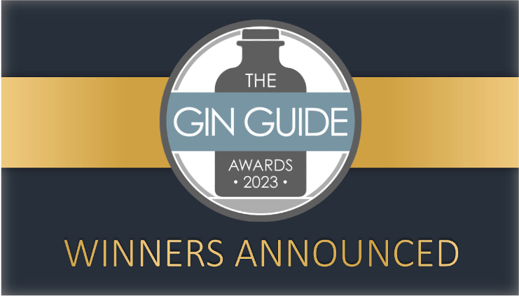

The Winners of The Gin Guide Awards 2023 have been revealed in a highly anticipated announcement that has once again grabbed the attention of the trade and gin lovers across the world. In particular, the quality and international diversity of the Winners has been eye-catching as the popularity and standard of gins from emerging gin markets has reached new levels alongside a strong showing of Winners from the UK, including Winners from Argentina, Armenia, Chile , Estonia and Latvia.
Hundreds of gins from over 35 countries around the world took part in The Gin Guide Awards 2023, in categories based on the most popular styles of gin and their countries of production, as well as Design & Branding and Environmental Sustainability categories.
The Winners are selected through a rigorous blind tasting process conducted by an esteemed panel of distinguished gin experts, including distillers, spirits buyers for retailers, authors, and mixologists. Each gin’s appearance, aroma, flavour, mouthfeel, finish and overall quality are assessed to determine the highest scoring gins, based purely on the spirit itself and with no influence from branding, marketing or the country of origin.
Global awards shine a spotlight on the quality of British gins while international gins’ success continues to soar:
Henstone Distillery in Shropshire (England) took centre stage with the ‘Distillery of the Year 2023’ Award, as well as being Winners in the Traditional Gin, Navy Strength Gin and Aged Gin categories. ‘Wonky Raspberry Gin’ from Herefordshire’s Penrhos Spirits was named ‘Product of the Year 2023’ after success in both the Flavoured Gin blind tasting category and the Design & Branding category, while also boasting environmental sustainability credentials.
Meanwhile, international gins achieved great successes, with Mezzanotte Gin from Italy being the highest scoring European Gin and claiming the ‘Best in Europe 2023’ accolade, while its producers Mezzanotte Distillery were named ‘New Distillery of the Year 2023’ having launched last year and produced two winning gins.
7k Distillery’s Modern Tasmanian Gin from Australia was named ‘Best in Australasia 2023’, Two Gingers Pink Pomelo Gin from Gember Distillery in South Africa was awarded ‘Best in Africa 2023’, Greater Than’s Broken Bat Gin from India scooped ‘Best in Asia 2023’, and ‘Best in The Americas 2022’ was awarded to Bosque Alta Montaña Gin from Argentina amidst a strong showing from South American producers.
The full list and details of Winners and Highly Commended gins are available on The Gin Guide website:
- https://www.theginguide.com/2023-winners.html
The Gin Guide Awards – The world’s largest dedicated gin competition:
Now in its 7th year, The Gin Guide Awards is an independent celebration of the historic, diverse, and growing worldwide gin industry. Recognised and respected globally by the trade and consumers alike for its rigorous and quality-focused approach and industry-leading judging panels, The Gin Guide Awards serves to highlight the exceptional products, distilleries, and people within the gin industry across the world. Keep an eye out for 2023 Winners and past Winners displaying their Awards proudly on their bottles, packaging, exhibition stands and marketing materials.
Head Judge Paul Jackson, the Founder and Editor of The Gin Guide, commented on The Gin Guide Awards 2023 and the standard of entries:
“The quality and diversity of gins has been absolutely remarkable. British gins and international gins alike showed the depth of skill in distillation and product development that continues to grow in the industry and that is undoubtedly becoming more prevalent in emerging gin markets. Gins from new and growing markets hugely impressed the industry-leading judging panels and showed how gin has truly cross borders and is an exciting product in markets across the world that are traditionally more connected with other spirits.”
“Huge congratulations and credibility go to all the Winners, Highly Commended gins and Finalists. The Gin Guide Awards names just a small number of Winners in each category to ensure genuine exclusivity and to protect the value of the awards and its proven ability to guide trade and consumer buying decisions. It is why being a Winner in The Gin Guide Awards has become one of the most revered achievements in the industry and previous Winners have used their success to take their businesses to the next level. I very much look forward to seeing this year’s Winners enjoying the benefits of their achievements in the same way.”
The full list of Winners, Highly Commended gins and Best in Country/Continent Awards are available at:
- http://www.theginguide.com/2023-winners
To register your interest in The Gin Guide Awards 2024, visit:
- https://www.theginguide.com/gin-awards.html
- ENDS –
For information, interviews, written comments or any questions, please contact:
Paul Jackson – Editor, The Gin Guide: awards@theginguide.com

