FOR RELEASE ON 25th JUNE 2018
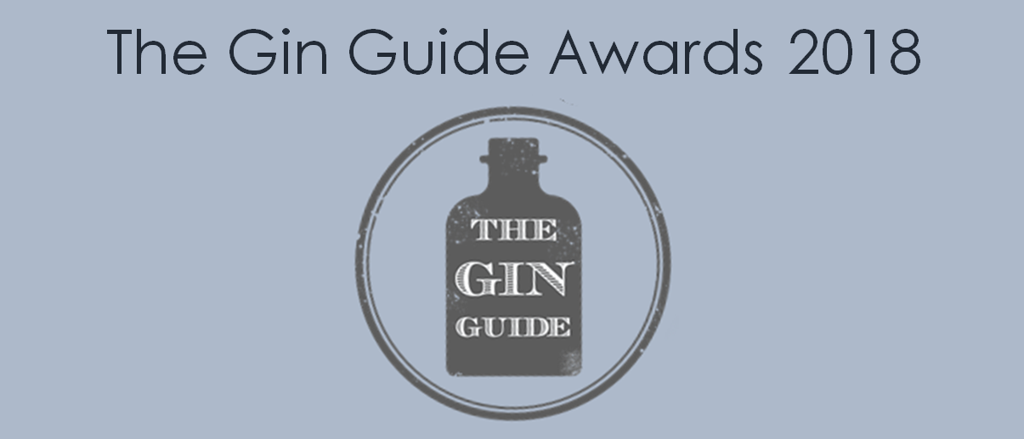
The Gin Guide Announces Global Gin Awards Winners
Newly launched and established gins from across the world have been awarded coveted titles in The Gin Guide Awards 2018. The annual global gin awards saw unprecedented levels of quality and a record number of entries as gins from 19 different countries were analysed and assessed by The Gin Guide’s judging panel of experienced distillers and industry experts.
Head Judge and Editor of The Gin Guide, Paul Jackson, described the awards and standard of entries, saying “The Gin Guide Awards is an independent celebration of our historic, diverse, and growing spirits category and the exceptional products, distilleries, and people within it across the world. The quality and diversity of entries is true testament to the gin industry and how it continues to grow and be embraced on a global level.”
The overall category winners of The Gin Guide Awards 2018 are listed below and the full details of regional winners for each category and shortlisted gins can be found online:
https://www.theginguide.com/2018-gin-awards-winners.html
Production Categories
- London Dry Gin: Winner – Biggar Gin (Scotland)
- Distilled Gin (Non-London Dry): Winner – Grace Gin (Greece)
- Compound Gin: Winner – Orkney Gin Company Johnsmas Gin (Scotland)

Style Categories
- Traditional Gin: Winner – Makar Gin (Scotland)
- Contemporary Gin: Winner – Caspyn Cornish Dry Gin (England)
- Flavoured Gin: Winner – Cuckoo Sunshine Gin (England)
- Old Tom Gin: Winner – The Ginsmiths of Liverpool Marshmallow Gin (England)
- Navy Strength Gin: Kirkjuvagr Arkh-Angell Storm Strength Gin (Scotland)

Regional Categories
- UK Gin: Winner – Makar Gin (Scotland)
- European Gin: Winner – Listoke 1777 Gin (Republic of Ireland)
- Rest of the World (Non-European) Gin: Winner – Underground Spirits Gin (Australia)

Industry Categories
- Gin Innovation: Winner – Underground Spirits Gin (Australia)
Scottish gins stole the show with four different Scottish winners, including two gins from Orkney, the recently launched Biggar Gin, and Glasgow favourite Makar Gin. Grace Gin has made a statement in putting Greece on the gin map, while Listoke 1777 Gin and Underground Spirits Gin showcased the exciting and innovative gin industries in Ireland and Australia respectively. English gins continued to show their pedigree with wins in the Contemporary Gin, Flavoured Gin and Old Tom Gin categories.
Entries were judged in blind tasting sessions across the hotly competed categories. Each gin is assessed using a detailed scorecard developed by The Gin Guide, featuring key characteristics including appearance, aroma, flavour, mouthfeel, finish and overall balance and appeal. Head Judge Paul Jackson was accompanied by Alex Griffiths - Founder of Griffiths Brothers Gin, Rhys James – Distiller at Wayfinder Spirits, Andy Burrows – Editor of Gin Rag, and Natalie Button – Founder of Gin Obsessions.
Paul Jackson commented on the winners, saying “The margins in judging were extremely close and so many entries deserve credit and recognition. Congratulations to the winning entries - the judges were hugely impressed with the overall calibre of entries, especially with the winners which received unanimous acclaim and high scores”.
Full details of winners, shortlists and categories can be found on The Gin Guide website and winning gins will be on show at The Gin Guide Awards’ Tasting Sessions over the summer. Join The Gin Guide mailing list to find out more: https://www.theginguide.com/gin-club.html
To register your interest in The Gin Guide Awards 2019, visit:
https://www.theginguide.com/gin-awards-2019.html

- ENDS -
For more information or for any questions, please contact:
awards@theginguide.com or +44(0)7846 807105.

